|  |
| --- |
| Circle Language Spec: Commands |

## Inactive Command Object Redirection

An inactive command object redirection makes an inactive command symbol a command reference.

An inactive command reference can point to another inactive command as well as to an active command object.

The picture below displays an inactive command, that redirects its definition to another inactive command.

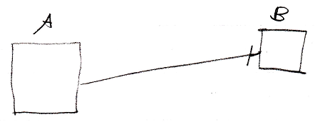

Inactive command symbol A is a square because it is an *inactive* command. Inactive command symbol A redirects to the inactive command symbol B. Symbol B is also a square because it is also an *inactive* command. The redirection from command A to command B is displayed as a solid line, which is an object line. The direction of the line is indicated by a line dissector, close to symbol B.

Symbol B could also be replaced by a diamond, because inactive pointers to active commands are allowed.

